**DAILY ONLINE ACTIVITIES SUMMARY**

|  |  |  |  |  |  |  |  |  |
| --- | --- | --- | --- | --- | --- | --- | --- | --- |
| **Date:** | **02/07/2020** | | | | | **Name:** | **SUJAYA** | |
| **Sem & Sec** | **IV sem & B section** | | | | | **USN:** | **4AL18CS090** | |
| **Online Test Summary** | | | | | | | | |
| **Subject** | | **-** | | | | | | |
| **Max. Marks** | | **30** | | **Score** | | | **-** | |
| **Certification Course Summary** | | | | | | | | |
| **Course** | **Blockchain Basics** | | | | | | | |
| **Certificate Provider** | | | **Greatlearning academy** | | **Duration** | | | **2.5hours** |
| **Coding Challenges** | | | | | | | | |
| **Problem Statement1:** Write a Java Program minimize the maximum difference between adjacent elements in an array. | | | | | | | | |
| **Status: Executed** | | | | | | | | |
| **Uploaded the report in Github** | | | | | **YES** | | | |
| **If yes Repository name** | | | | | **Online-coding** | | | |
| **Uploaded the report in slack** | | | | | **YES** | | | |

Online Test Summary: No internals conducted today.

Online Certification Course Summary: Today is the last session of this certification course.

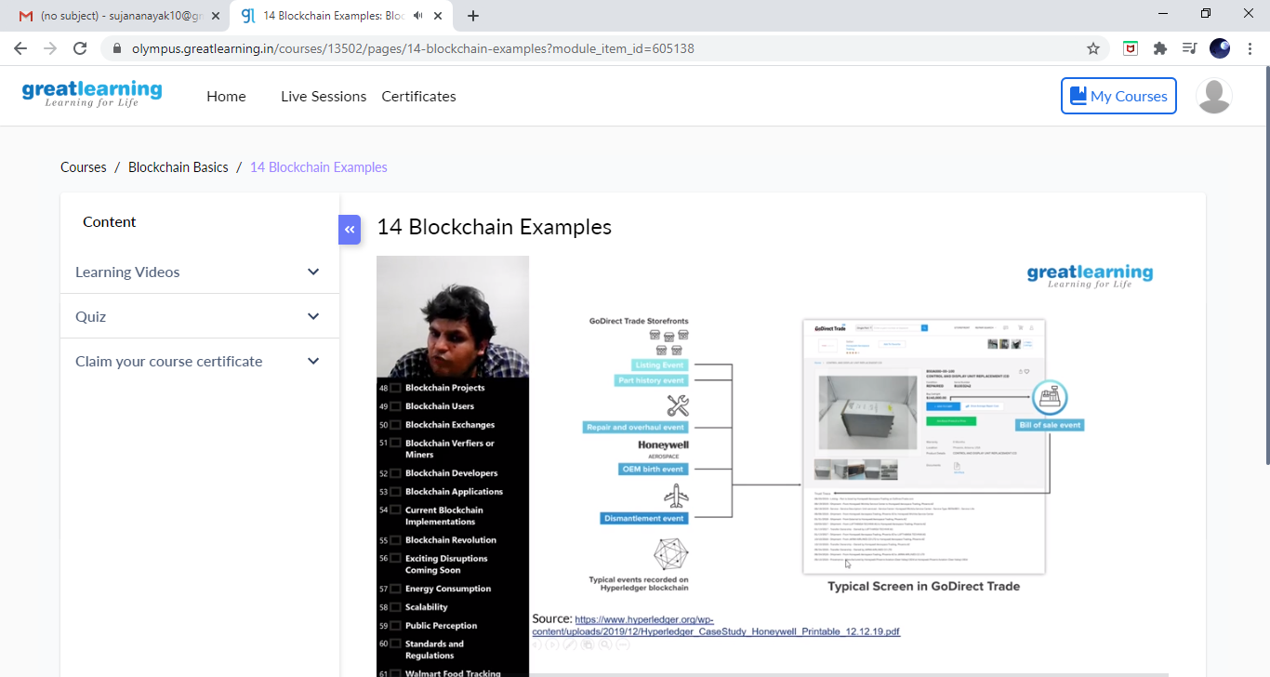

This is the Snapshot of the today’s session.

**Online Coding Summary: Today I had received one program from prof. Shilpa CSE Dept. The program is mentioned above in the coding challenges. I have also uploaded it to my Github repository.**

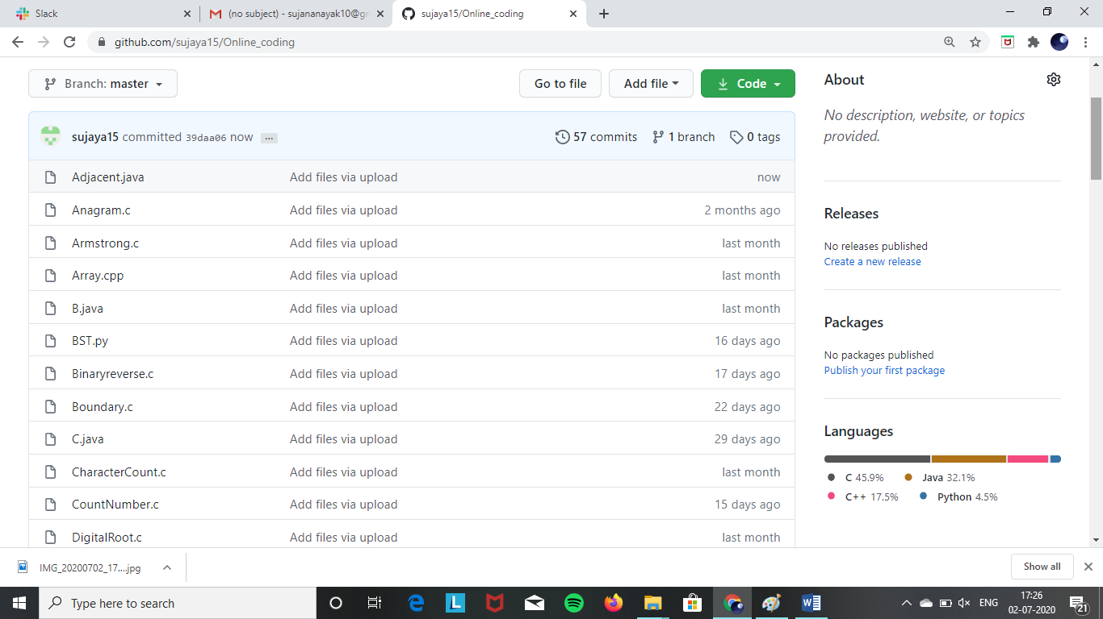

**This is the Snapshot of my Github repository** where I have uploaded the code. File name is Adjacent.java

Online Training: Today I had attended the online training organized by CSE Department AIET. The training was on C++ programming language done by Prof. Shruthi Shetty J. CSE Dept. After the session the quiz was conducted.

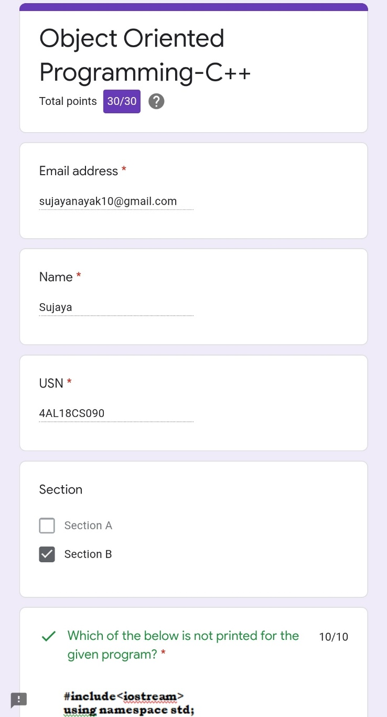

**This is the Snapshot of the quiz attempted and scores obtained.**